Make Decisions for Your Future
From High School through Life

A New Day for Transition: Self-Directed Supports...

The coming of Family Care and IRIS, with Self-Directed Supports (SDS) opens up exciting, new opportunities for transitioning youth who are eligible for long-term support.

- Where do you want to live and who do you want to live with?
- Do you want to work or do you want to go to school?
- How do you balance benefits and your goals for your life?

Dennis Harkins will help us think about what is now possible with SDS. Dennis has worked for many years across North America helping self-determination and self-directed supports become a reality for people needing long-term support. He is now working with people with disabilities and their families across Wisconsin to help people create support that makes sense to them.

Tammi Biddle and her daughter TaraLyn will attend to share first hand experiences navigating the systems of Family Care and IRIS. They’ll share a story of frustrations and successes from the view point of a parent/guardian of a child with autism, and be available to answer questions.

Columbia County Aging and Disability Resource Center (ADRC) staff members will also be on site as a resource to members in attendance.

Join us on Tuesday, March 2nd from 5-7 p.m. at the CESA 5 office - 626 E. Slifer Street in Portage.
Dennis and others with expertise will share information to help you make plans for your future.

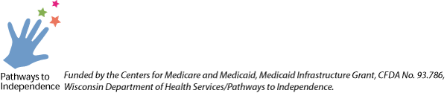
This event is FREE!
Dinner, refreshments & information packets will be provided.
Register at: http://login.myquickreg.com/event/event.cfm?eventid=649
or if you don’t have access to the internet, please contact
Wendi Nelson, Transition Coordinator at (608)697-1704

Sponsored by CESA 5
Funded by the Centers for Medicare and Medicaid Services, Medicaid Infrastructure Grant, CFDA #93.768, WI Department of Health Services/Pathways to Independence

